Story 03 - Book Filter

## Description

As a user

I want to filter the book overview

On price, title and color

## Wireframe

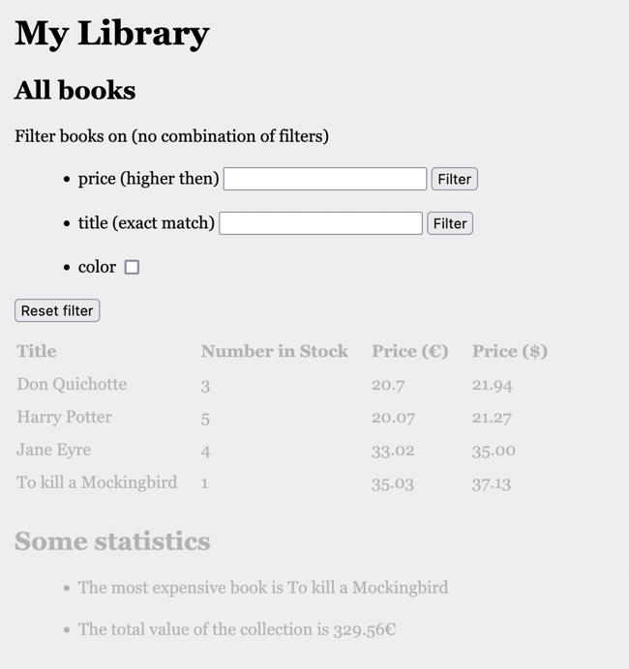

## Acceptance Criteria

* The screen shows three filter options
  1. Filter books on price: only books with price more than given value are shown
  2. Filter books on title: only the book with the given title (exact match, not case sensitive) is shown
  3. Show only books that are in color (when check box is checked).
* Filtering only starts after clicking on the filter-button or checkbox.
* Filter values are shown in table overview
* Filters cannot be combined

## API

* API for “Filter Books on Price”

|  |  |
| --- | --- |
| **Filter Books on Price** | |
| **Request** | GET |
| **URL** | [http://localhost:8080/api/book/search/priceMoreThan?price={price}](http://localhost:8080/api/book/search/priceMoreThan?price=30) |
| **Input** | Price to be filtered as query string (number) |
| **Output: Happy Case** | JSON list of books |
| **Output: Unhappy Case** | Empty list [] when there are no books found. |
| **Acceptance Criteria** | Returns all books with price more than the given price. |

* API for “Filter Books on Title”

|  |  |
| --- | --- |
| **Filter Books on Price** | |
| **Request** | GET |
| **URL** | http://localhost:8080/api/book/search/title/{title} |
| **Input** | Title to be searched as path variable |
| **Output: Happy Case** | JSON *list* of books (<> book object!) |
| **Output: Unhappy Case** | Empty list [] when there are no books found. |
| **Acceptance Criteria** | Returns the book with given title as list of JSON book objects |

* API for “Show Books in Color”

|  |  |
| --- | --- |
| **Show Books in Color** | |
| **Request** | GET |
| **URL** | <http://localhost:8080/api/book/search/inColor> |
| **Input** |  |
| **Output: Happy Case** | JSON list of books |
| **Output: Unhappy Case** | Empty list [] when there are no books found. |
| **Acceptance Criteria** | Returns all books in color |

## Technical Requirements

* Book objects have fields “title” (String), “numberInStock” (int), “price” (double), “inColor” (Boolean), “priceInDollar” (double).